ARTICLE TITLE WITH FONT ARIAL BOLD 14 (STYLE SUST-TITLE)

Name Familyname¹, Name Familyname¹, Name Familyname², Name Familyname³* [Arial, 12pt, Bold]
¹ Dept. of Environmental Engineering, Democritus University of Thrace
² Dept. of Physics, National and Kapodistria University of Athens
³* Dept. of Mechanical Engineering, Aristotle University of Thessaloniki
541 24 Thessaloniki, Greece, e-mail: author@address.gr [Arial, 12pt, Style: SUST-Affiliation]

ABSTRACT [ARIAL 12pt, Bold, Style: SUST-Abstract Title]
Paper title, author names and affiliation, abstract and keywords should be limited to one page. At least 3 keywords are required. [Arial 10pt (style SUST-Normal]
Keywords: … … …
- Introduction [Arial 12pt, Bold, Space before: 12, Space after: 6, Style: SUST-Heading-1]
The main text is written in [Arial 10pt, Space before: 0, Space after: 6, Style:SUST-Normal]. with no indentations on the left or right, and no blank lines between paragraphs. However, there is a 6pt spacing between paragraphs. The page size is A4 with a 2.5cm margin all around. The text length must be between 6 and 12 pages, including the introduction and references.
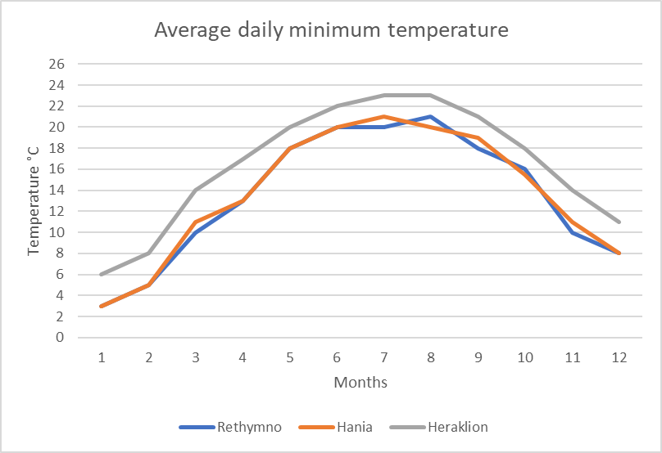
Figure 1: Εvolution of installed res power plant capacity [Arial 10pt, italic, SPACE BEFORE: 6, SPACE AFTER: 12, STYLE: SUST-CAPTION.]
- METHODOLOGY [Arial 12pt, Bold, Space before: 12, Space after: 6, Style: SUST-Heading-1]
It's important to follow the provided formatting. To assist authors, the formatting is given in the form of embedded styles, which should be followed. Texts that don't adhere to the provided formatting will be returned for correction.
  - Second-level Subheading [Arial 10pt, Bold, Style: SUST-Heading-2]
Authors can write their paper's text directly onto the template, naturally deleting the style guidelines within the brackets.
    - Third-level Subheading [Arial 10pt, Italic, Space before: 6, Space after: 6, Style: SUST-Heading-3]
It's recommended to fill each page completely and avoid leaving blank lines.
- RESULTS
For tables, the caption is placed above the table, as shown in the following example:

Table 1: Percentage of wind energy absorption for off-grid installations [Arial 10pt, Italic, Space before: 6, Space after: 6, Style:SUST-Caption.]
Average wind speed (m/s) | Wind Penetration Level - WPL
 | 0% | 10% | 20% | 30%
0.0 | 100% | 100% | 100% | 100%
4.9 | 100% | 98% | 96% | 93%
5.6 | 100% | 98% | 94% | 90%
6.9 | 100% | 97% | 92% | 84%
8.3 | 100% | 96% | 90% | 82%

An effort should be made for each table to appear on a single page. If this isn't possible (e.g., for large tables), the table caption should be repeated on the part that extends to the next page, followed by the indication "continued.
Οι εξισώσεις εισάγονται σε νέα γραμμή, με αρίθμηση κατ’ αύξοντα αριθμό, όπως π.χ.
$f(x)=a⋅y^{2}+b⋅y$ (1)
- CONCLUTIONS
Images and tables are center-aligned. Figures, diagrams, and photos should be of sufficient resolution, and embedded fonts should not be smaller than 7pt.
Bibliographic references within the text are given in square brackets in ascending order (e.g., [1]).
ACKNOWLEDGEMENTS [Arial 11pt, Bold, Style: SUST-Heading-References]
If desired, acknowledgments are written in the final section before the bibliography, without numbering in the section title.
REFERNCES [Arial 11pt, Bold, Style: SUST-Heading-References]
[1] Ning, X., and Lovell, M. R., 2002, “On the Sliding Friction Characteristics of Unidirectional Continuous FRP Composites,” ASME J. Tribol., 124(1), pp. 5-13. [Arial 11pt, Space before: 0, Space after: 6, Style:SUST-References]
[2] Barnes, M., 2001, “Stresses in Solenoids,” J. Appl. Phys., 48(5), pp. 2000–2008.
[3] Jones, J., 2000, Contact Mechanics, Cambridge University Press, Cambridge, UK, Chap. 6.
[4] Lee, Y., Korpela, S. A., and Horne, R. N., 1982, “Structure of Multi-Cellular Natural Convection in a Tall Vertical Annulus,” Proc. 7th International Heat Transfer Conference, U. Grigul et al., eds., Hemisphere, Washington, DC, 2, pp. 221–226.
[5] Hashish, M., 2000, “600 MPa Waterjet Technology Development,” High Pressure Technology, PVP-Vol. 406, pp. 135-140.
[6] Watson, D. W., 1997, “Thermodynamic Analysis,” ASME Paper No. 97-GT-288.
[7] Tung, C. Y., 1982, “Evaporative Heat Transfer in the Contact Line of a Mixture,” Ph.D. thesis, Rensselaer Polytechnic Institute, Troy, NY.

*The length of a research paper should be 6–8 pages (including first page (Name, Affiliations and Abstract) AND references).

